MODULE 7 UNIT 1

Activity submission

Learning outcomes:
LO1: Compare a use case diagram and a use case narrative.
LO2: Evaluate how to create a functional decomposition diagram.
LO3: Decide how to write user stories and group them into epics.

1. Instructions and guidelines (Read carefully)

Instructions
1. Save your file as: First name Surname Activity Submission 7 – e.g. Lilly Smith Activity Submission 7. NB: Please ensure that you use the name that appears in your student profile on the Online Campus.
2 Write all your answers in this document. Do not adjust answer table dimensions or font formats. If your answer does not fit into the table, then your answer is too long. Diagrams that are illegible, distorted, too small to view, or not entirely contained within the allocated answer space risk not being assessed.
3 Submit your assignment in Microsoft Word only.
4 Do not delete the plagiarism declaration or the assignment instructions and guidelines. They must remain on your assignment when you submit.
PLEASE NOTE: Plagiarism cases will be penalised according to the Head Tutor’s and GetSmarter's discretion.
IMPORTANT NOTICE: Please ensure that you have checked your course calendar for the due date for this assignment. This calendar is available on the Online Campus.

Guidelines
1 This activity submission is based on the activity submission scenario for Module 7. You can download the activity submission scenario document from the Online Campus.
2 There are initially nine pages and three questions in this assignment.
3 Each question in this assignment relates to its corresponding unit of the module. Complete each question as you work through each unit.
4 Make sure that you have carefully read and fully understood the questions before answering them. Answer the questions fully but concisely and as directly as possible. Follow all specific instructions for individual questions (e. g. “list”, “in point form”).
5 Answer all questions in your own words. Do not copy any text from the notes, readings or other sources. The assignment must be your own work only.
Plagiarism declaration:
1. I know that plagiarism is wrong. Plagiarism is to use another’s work and pretend that it is one’s own.
2. This assignment is my own work.
3. I have not allowed, and will not allow, anyone to copy my work with the intention of passing it off as his or her own work.
4. I acknowledge that copying someone else’s assignment (or part of it) is wrong, and declare that my assignments are my own work.

2. Mark allocation
Each part of the question receives a mark allocation. However, you will only receive a final percentage mark and will not be given individual marks for each question. The mark allocation is there to show you the weighting and length of each question. Please note that line limits for each question do not indicate mark allocation. You are required to stick to the line limits. Answer all questions clearly and succinctly.
Question 1: (Unit 1) Construct a use case diagram and use case narrative 80
Question 2: (Unit 2) Create a functional decomposition diagram (FDD) 40
Question 3: (Unit 3) Write user stories and group them into epics 30

TOTAL 150 marks

3. Assignment questions
How to create your diagrams and insert them into this document:
Draw.io is recommended and technical support is offered if you use this software. If you draw your diagram by hand and photograph it (instead of scanning it) ensure the lighting is good so that colours contrast well and text is legible. Once you have created your diagram, either save it as a JPEG and insert it into the appropriate answer box, or take a screenshot and paste it into the answer box. To insert the file, put the cursor in the answer box, then insert the JPEG file containing your diagram.

Question 1
(Please note that this question relates to the content in Unit 1.)

1.1 Use case diagram

Instructions:
Based on the section headed “Use case diagram and use case narrative” in the scenario document for Module 7, create a use case diagram for Kabeljou and insert it into the table below. (Reminder: minimum test size in your diagram is Arial size 9. Review the diagram instructions in Module 4.)
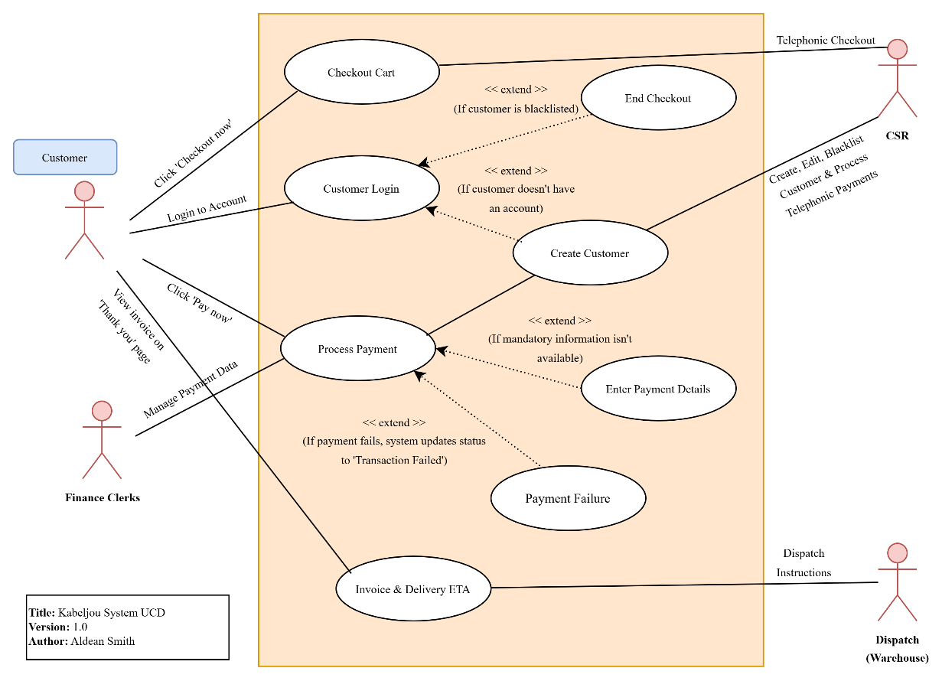

1.2 Use case narrative
Based on the same section of the scenario document, complete the use case narrative for Kabeljou on the next page.
Enter your answers in the unshaded cells only. You do not need to fill all the unshaded cells; only write as much as you deem necessary to complete the use case specifications. Do not change or delete any of the use case’s specifications that are already written in the table. For each step in your normal and alternate courses, use one row per step.
Specifically, you need to complete only these sections: Author, Normal course, and Alternate course(s).

Author: | Aldean Smith
Owner: | Marius
Use case name: | Check out cart
Actor: | Customer
Description: | A customer can place an order by clicking the “Checkout now” button in the catalogue. The system will collect payment, then issue an invoice simultaneously on the “Thank you” web page and by email.
Normal course: | N1. Customer clicks “Checkout now” on the catalogue page
 | N2. System confirms that the cart is not empty
 | N3. System confirms if customer is logged in
 | N4. System presents editable customer and order info on cart page
 | N5. Customer clicks “Pay now”
 | N6. System confirms if mandatory customer data is present
 | N7. System prompts customer to enter payment details if not present
 | N8. Customer submits payment
 | N9. System checks if customer is in good standing and order uniqueness
 | N10. System processes the payment through the integrated gateway
 | N11. If payment is successful, system updates order status to “Paid”
 | N12. System generates an invoice with delivery ETA
 | N13. System displays a “Thank you” page with invoice and delivery ETA
 | N14. System sends the invoice and ETA via email to the customer
 | N15. System sends dispatch instructions to the warehouse via email
Alternate course(s): | A1. If cart is empty, system disables “Checkout now” button
 | A2. If customer not logged in, log in or create new customer record
 | A3. If mandatory data is missing, system highlights fields to be filled in
 | A4. If payment fails, system updates status to “Transaction failed”
 | A5. If user is blacklisted or order is duplicated, system ends checkout process
 | A6. If cart is abandoned, system changes status to “Abandoned”
Pre-condition(s): | At least one stock item exists in the cart.
 | The “Checkout now” button is available.
Assumption(s): | User is viewing any catalogue page in a browser.
Successful post-condition(s): | S1 Order ‘Status’ is "Paid"; AND
 | Invoice and delivery ETA emailed to customer; AND
 | Dispatch instruction emailed to warehouse.
Failure post-condition(s): | F1 ‘Status’ is "Abandoned" OR
 | F2 ‘Status’ is "Transaction failed" if payment collection fails OR
 | F3 ‘Status’ is "Suspended" AND
 | 'Blacklisted' is "True" AND / OR
 | 'Duplicate' is "True"

Question 2
(Please note that this question relates to the content in Unit 2.)

Instructions:
Create a functional decomposition diagram for Kabeljou based on the scenario document for Module 7 and insert it into the table on the next page (Reminder: minimum text size in your diagram is Arial size 9. Review the diagram instructions in Module 4.)

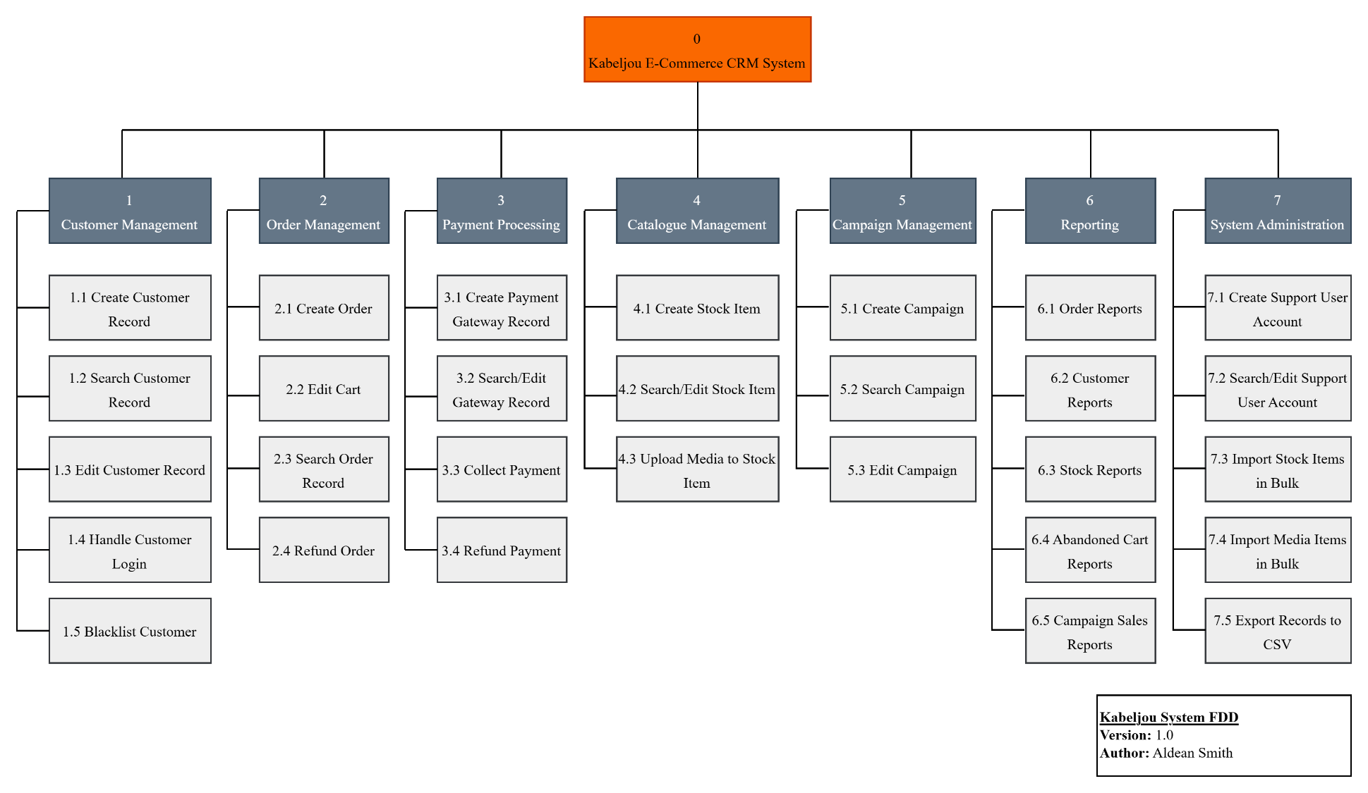

Question 3
(Please note that this question relates to the content in Unit 3.)

Instructions:
Based on the section headed “Stories” in the scenario document for Module 7, write a formal title for each user story by applying Cohn’s three-part structure, then name the two epics in the scenario and allocate the stories to their appropriate epics. Write your answers in the right-hand column of each table below. You do not need to fill all rows.
Do not adjust the tables’ dimensions or the font size. Use only one table row per story.
Epic 1 name: | Manage Customer Orders
User stories for epic 1  (Write one story per cell) | As a Customer Sales Rep, I want to search for a customer account so that I can assist with new orders.
 | As a Customer Sales Rep, I need to place phone orders so that customers can order telephonically.
 | As a Customer Sales Rep, I need to process payment for an order so that I can confirm payment status before dispatch.
 | As a Customer Sales Rep, I need to view order history so that I can assist with reorders.
 | As a Customer Sales Rep, I want to search for an order so that I can flag duplicate orders.
 | As a Customer Sales Rep, I want to add a stock item to the cart so that I can assist customers with their online orders.
 | As a Customer Sales Rep, I want to cancel orders so that I can fix errors before dispatch.

Epic 2 name: | Manage Customer Accounts
User stories for epic 2  (Write one story per cell) | As a Customer Sales Rep, I need to flag duplicate orders so that we avoid processing mistakes.
 | As a Customer Sales Rep, I need to create a customer account so that I can assist with new orders.
 | As a Customer Sales Rep, I need to blacklist customers so that I can follow policy
 | As a Customer Sales Rep, I need to refund an order so that issues are resolved quickly.
 | As a Customer Sales Rep, I need to edit customer details so that customer records stay correct.
 | As a Customer Sales Rep, I want to check delivery ETAs so that I can inform customers accurately.
 | As a Customer Sales Rep, I want to escalate complaints so that issues are resolved quickly.

